MyTaxi: Android Task for Middle developers.

This is the test task which is specialized for middle android developers. There are some points which need to be considered whilst working on this task. They are the followings:

* Clean code
* Methods, functions should be named properly
* The design of the app should be adaptive for different screen sizes
* The proper ripple effect when buttons are clicked
* The color of texts
* The font of texts
* Code is not required to be commented but it should be written in a way where there is no need to explanation
* Platform:Android (Tab is not required)
* MinSdk 23
* Targer Sdk 31
* Device orientation: portrait

The task is designed to check how a developer approaches UI, design pattern and clean architecture

* Code should be written in Kotlin (not Java)
* Google Map
* UI elements should be adaptive

**What to do:**

* In order to understand this task, you can go to this [link](https://www.figma.com/file/jErDc72rsthv2boR0s8Bp1/Test-for-Android?node-id=0%3A1) and mvp version of the application which you are about to develop. You can also see the flow of the application in figma file (it is better to install mytaxi client app from google play to fully understand all the details)

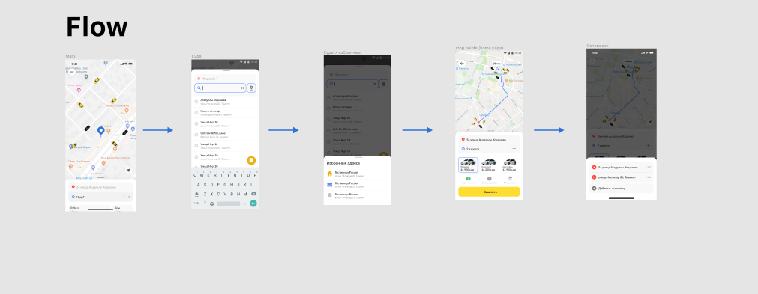

* The task consists of five screens:

1. Main Screen

-google map with a Pin

-bottomsheet

- when Куда? Is pressed in bottomsheet in MainScreen, it should take to SearchScreen

- when Pin changes on MainScreen, it should set new address as it is hown below   
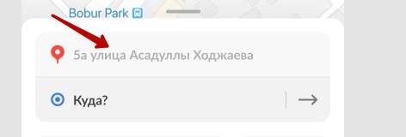

1. Search Screen (BottomSheet)

-When user clicks to map button, app should open another screen where user can pick address from map as it is shown in the photo below

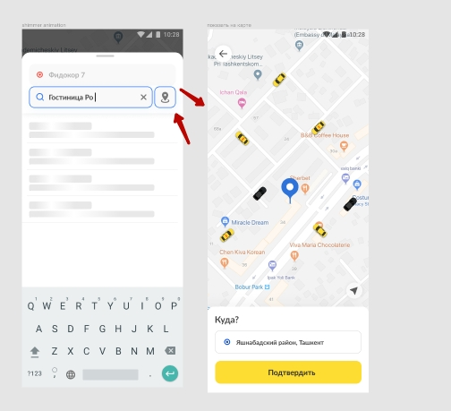

-When user clicks to search fields like for point a or point b, there should be animation. It can be seen on the photo below.  
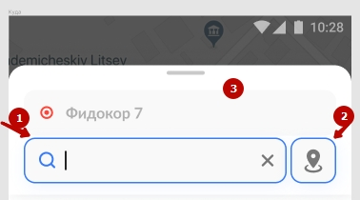

-When user clicks to Fidokor 7(point a) here, selected 1 and selected 2 moves up, when point b is selected again, selected 1 and selected 2 moves down.

-When user clicks yellow button on the bottom it opens favorite address Screen  
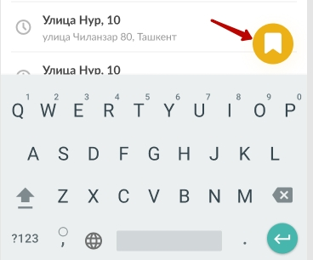

- In order to search address, you can use this api <https://testrouting.mytaxi.uz/v2/search> with params limit, lattitude, longitude and query. The full description about sending right request to the api is shown below.

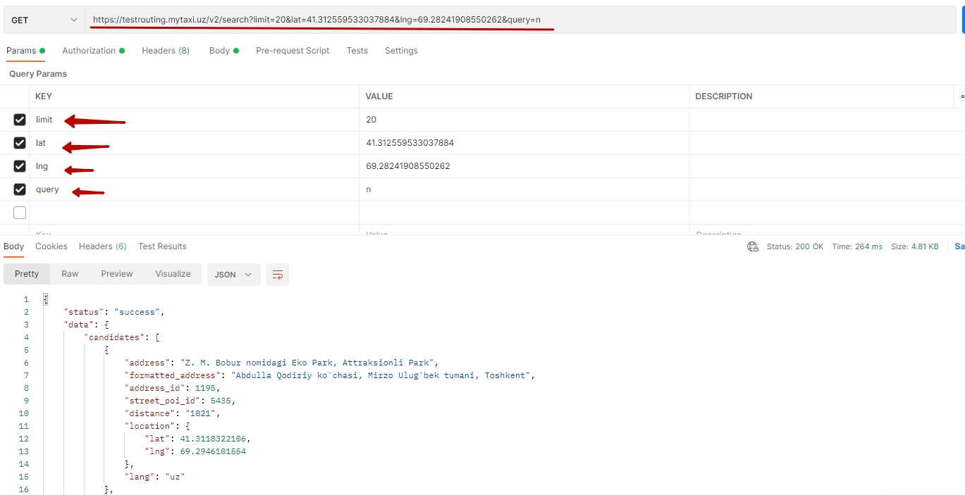

-Search address can be tricky here. 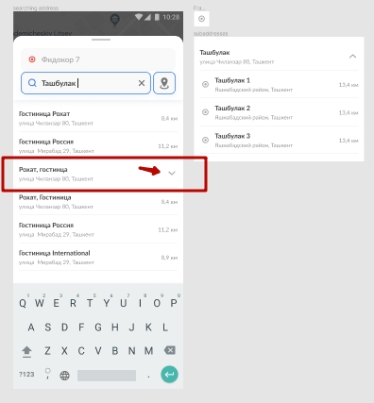

The arrow_down icon should be shown according to address_id field. If this field is null, then we have to show arrow icon in the address.

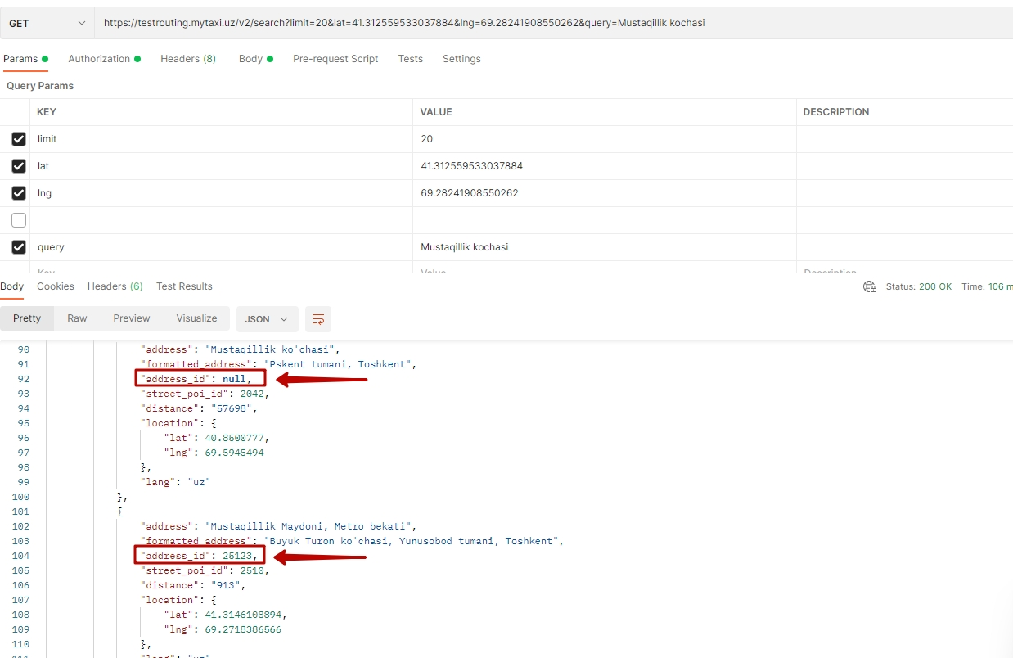

-when user clicks to search result item, if address_id is NOT null, it should set address to point b. if address_id is null, it should send request to server for child addresses. For example, user searches Mustaqillik kochasi, server gives this result, as you can see address_id is null, when user clicks to that item where address_is null, it should send another request with same API but without query. In Addition to this, the developer should add street_poi_id field to the request.  
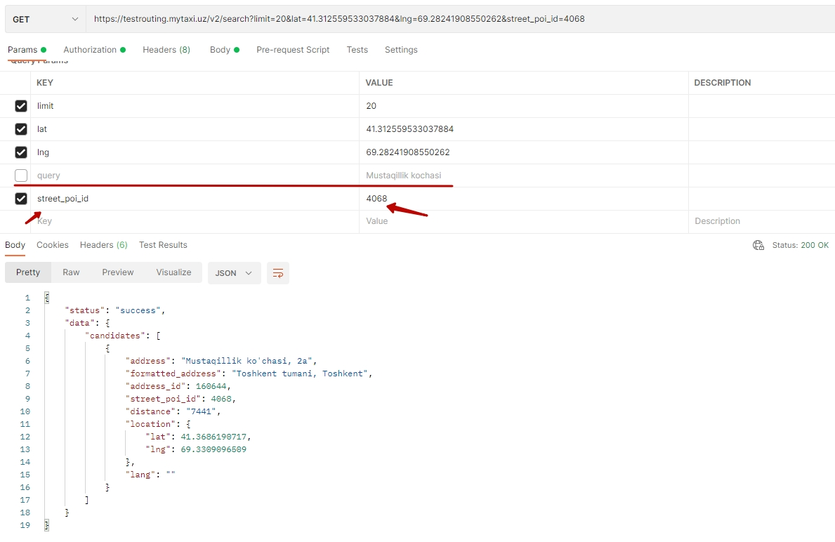  
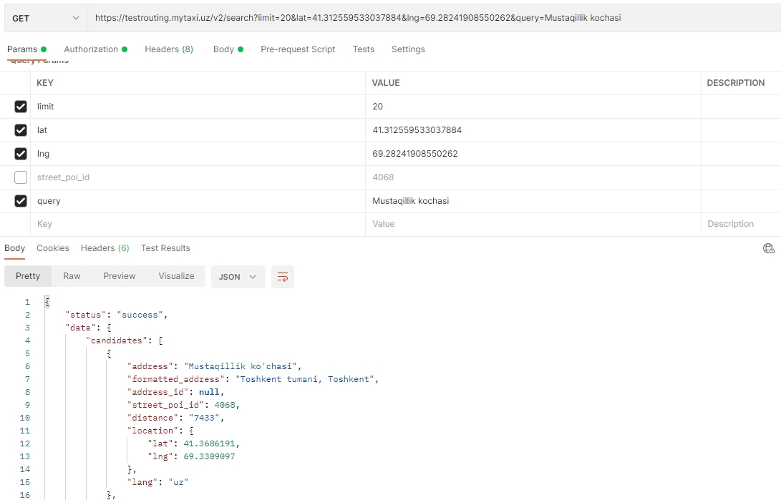

The result of child items of the search should be shown as below.

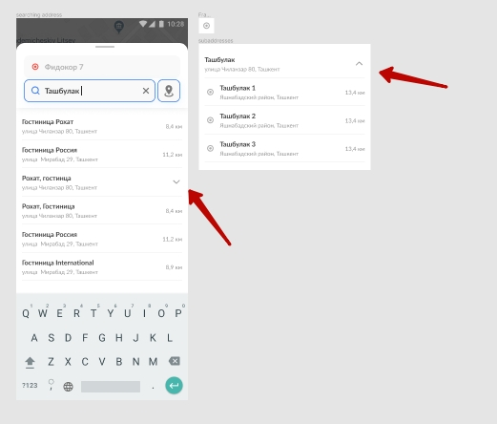

1. Favorite Address Screen (BottomSheet)

-The developer can add sample addresses to favoriteAddress by implementing Room database (add three hardcore addresses)

-When user clicks favorite item it should set selected address to point a or point b

1. Stop-Point (BottomSheet)

-After User added point b, user should be able to add more points up to 3 stop points between point a and point b. The selected + button should take to another Screen where use can add stop point.

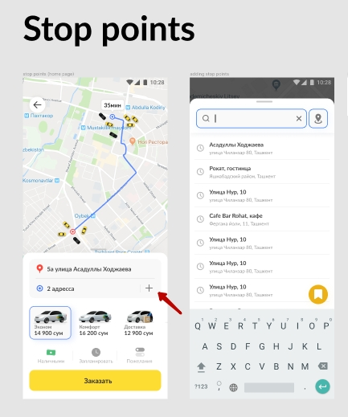

-If user click 2 адресса field in the photo above, it should open stop points bottom sheet where user can add more stop point and change stop point’s position.

- In order to draw line between points, we will provide api

(https://api.mytaxi.uz/v2/route/from) where the developer should send points and server returns connecting lattitude and longitude. The photo below shows how to request points in a right way

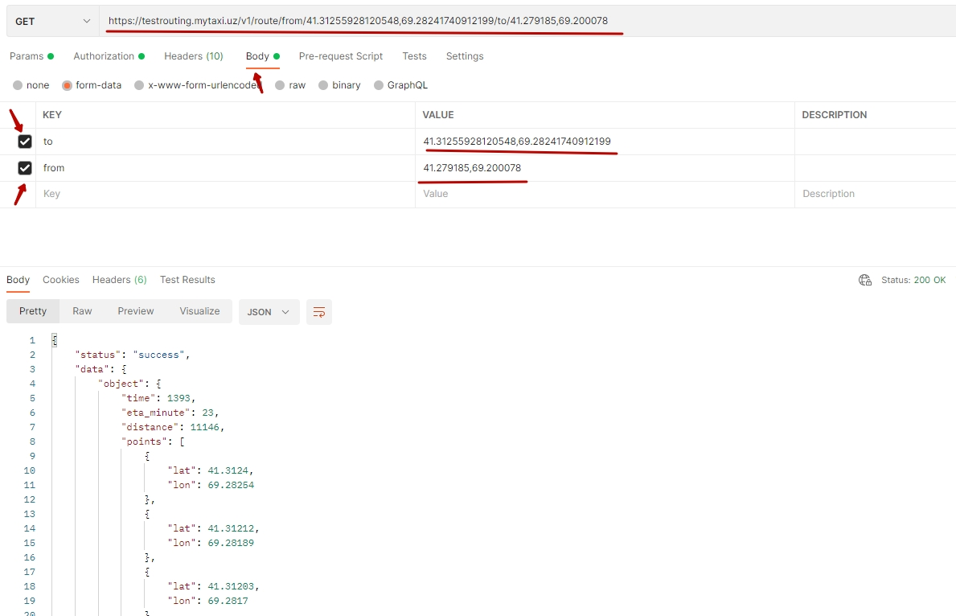

In order to access server, the following credentials are provided:  
host: https://testrouting.mytaxi.uz

api_key: 679e096b28bffbb5d6c3a888ecfe8cf46343eee3

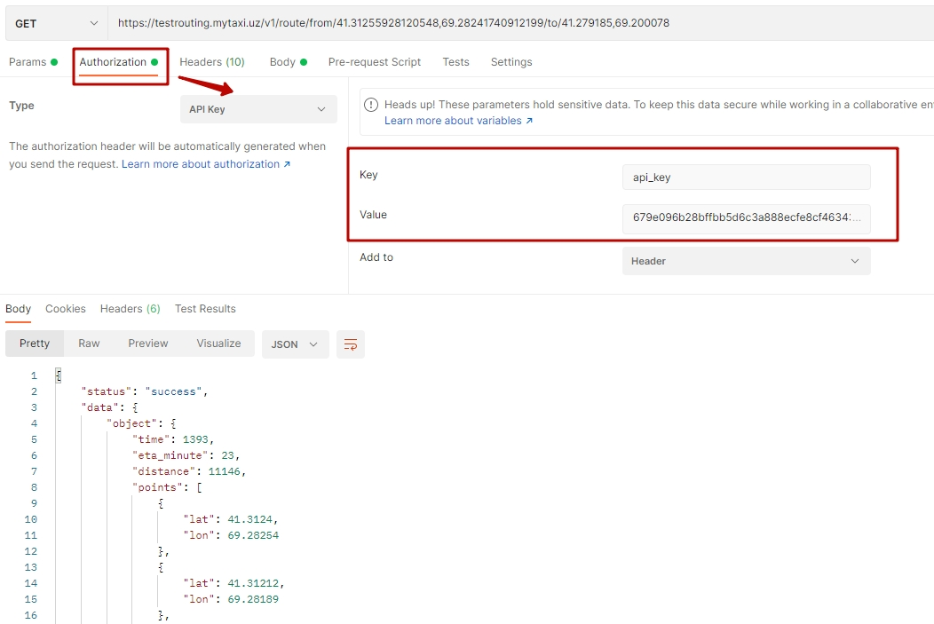

If you have troubles with understanding task, you can install mytaxi client app from google play you can see basic functions there.  
  
**After you have complete task please provide us github link where we can see your implementation and apk file.**